REWMOS Workshop Minutes
Nuru Maishani

Workshop Venue: Golf Hotel Kakamega

8th August 2019

Solibrium Limited
Tel: +254709753104
P.O Box: 1348-50100
Email: info@solibrium-solar.com
Website: www.solibrium-solar.com

REWMOS Workshop Minutes

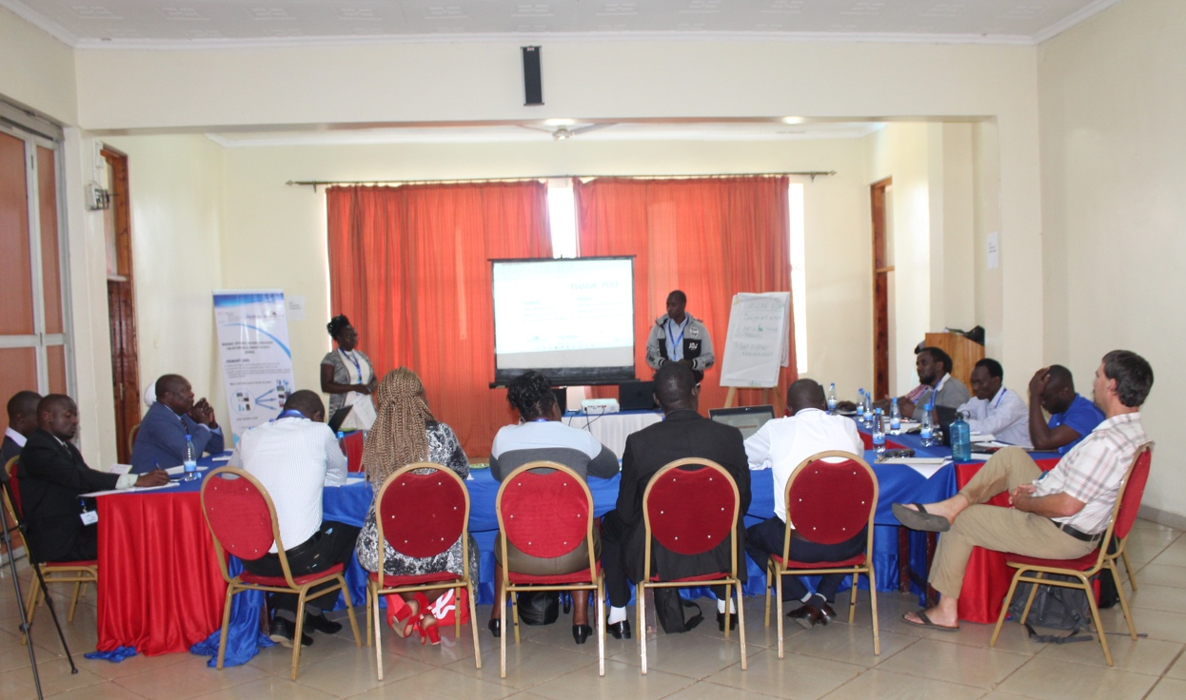

Mark Lung
- Transition from linear to circular economy
- Steps include
  - Design out waste
  - Practice reuse, maintenance, repair, remanufacture, and recycle.
  - Government should create an environment to support entrepreneurs on E-Waste.
  - Continue using products for as long as possible
    - Eg: solar batteries rebooted in postal service vehicles in Switzerland
  - Government creates environment that supports circular economy
    - Instead of increasing taxes, give opportunity for innovation and support entrepreneurs
- E-waste is not a menace, it’s an opportunity

Mr. Palapala: CGK
- E-waste is a problem but what are the solutions?
- Encourage thinking more about E-waste from an individual point of view.
- People as individuals can/are contributing
- Teach in schools how to handle e-waste
- Due to the large following, we should use churches & pastors to preach negativity from e-waste.
- Consider sensitizing schools on cheap and low-quality products and wastes being damped in schools as donations.

Essau: Solibrium Operations Manager
- Solibrium distributes solar home systems, but also has negative impact on environment
- Want to involve community to conservation, introduce ideas and involve them in decision making

Hardley Malema: Resource efficiency & waste management of solar products
- Aim to work together with other companies to tackle issues of e-waste
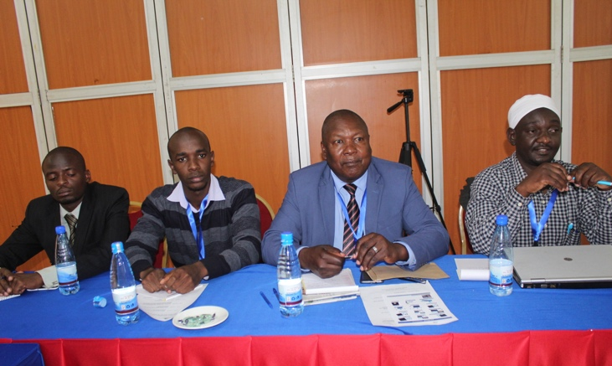
- Lithium ion: hazardous material
- Things done:
  - Understand usage patterns
  - Educate users
  - Create awareness
  - High level engagement
  - Life cycle analysis
- Most solar kits are pay-as-you-go with deposit then small payments

Edwin Kipruto: Best practices used by Solibrium
- To extend lifespan of products
  - Battery lasts for only 3 years because of lack of maintenance
- Best practices include:
- Provision of user manuals with graphics
- Firmware and software updates.
- Biodegradable packaging materials.
- Genuine spare parts.
- Provision of warranty for products through manufacturers
- Right tools for technicians
- Continuous training to remain competitive and updated on new designs
- Establish regional repair centre (in Nairobi) or partner with other people to repair
- D-light refurbishes solar equipment

Chris: What Next?
- Continued research on aspects of solar e-waste in Western Kenya. How?
  - Scale and number of picosolar and SHS users
  - Distribution and pattern of use of solar products to identify reasons for failure
  - Understand the volume of e-waste and methods people use to discard it
- Develop a database of solar users & solar e-waste
  - Map availability and distribution of e-waste including pricing, accessibility and component type
- Develop a database of formal and informal sector in Western Kenya to repair and recycle
  - Map availability and distribution of fundis

- Goal: to generate Private Public Partnership (PPP)
  - Work with formal and informal sector so move forward as a block
  - See commitment and roadmap of how will finalize partnership

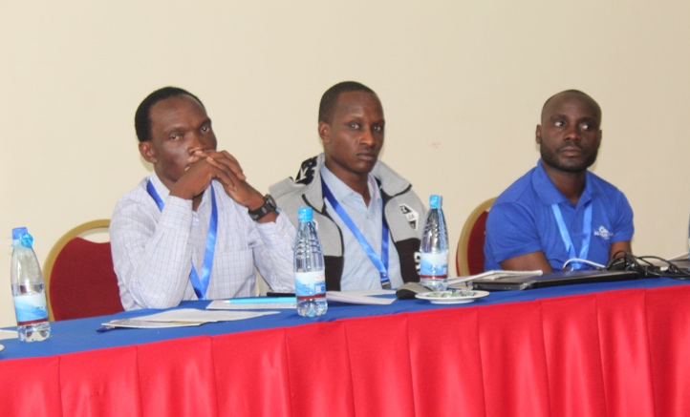
Questions from audience:
- Create collection points through partnering
- Some counties charge for transportation of e-waste
- Talk to county governors so come up with agreement
- Would classifying e-waste as raw material aid to avoid charges

Partnership Discussion
- Thuo:
  - Awareness to local communities, schools & churches
  - Hybrid business model where companies complement each other to reduce waste.
  - Exchange household items for electronics
  - Incentivize people to give own e-waste so they don’t feel cheated
- Mark:
  - People are lazy in the US; for recycling, people have to pay so use online platforms and e-waste businesses come and collect from home
- Dlight
  - Take product at a fee and send person to verify problem (retention manager)
- Chris:
  - Dlight is a solar retainer; what should Solibrium do to develop partnership?
- Book an appointment to discuss terms.
- Partnership agreement.
- Share Solibrium’s client base with Dlight to give to their retention officers to help collect wastes.
- Dlight:
  - Dlight has spare parts of batteries and lights
  - Partnered with Light Africa
  - Partner in life expansion
  - Need to know client database of Solibrium and come to agreement
  - Share information with retention officers
- Vihiga County: create package deal of solar to help with the pending electricity bill
- Radio: Lubao FM
  - Train “our” personnel
  - Looking at future, county government has bigger part to play; invest as county government to have new curriculum because solar is taking over society
  - Train youths on solar
  - Company training is extra cost, so government should take responsibility to have people fully developed and trained
  - Tell us what you want people to know
  - Public awareness: how to target audience?
    - Everyone is a part of target audience with different ways of advertising
    - Sales team should be part of the conversation
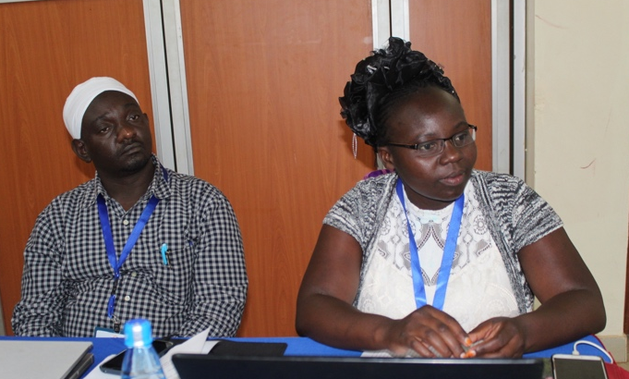
- Chris:
  - As Solibrium, power in collecting information
  - How do we come together to collect information?
- Dlight:
  - Wafundis and GIZ have very good structure to make sure solar products reach end user
  - Generation Kenya trains every sales person and look for where to attach people that they have been training
  - Lots of e-waste has been stored in national government offices and classify it as raw material
  - We are seeking your direct involvement in our work
    - Develop collection centers, which would make it easier to work from there on
- Gilfine:
  - Government to incentivize people, but there are gaps in information; is there any platform that we can access?
- Thuo:
  - Use avenues of schools and churches

Aceleron
- Based in Birmingham with 2 solar home systems (B-box)
- Lithium ion batteries; not welding but compression
- Batteries don’t die, they just degrade, so can be re-used for up to 2- 2 ½ years
- Also have power-wall like Tesla’s (35% of cost is inverter)

